A000-Afr-Zaire-Songye-Kifwebe-Shield-early 20 th c

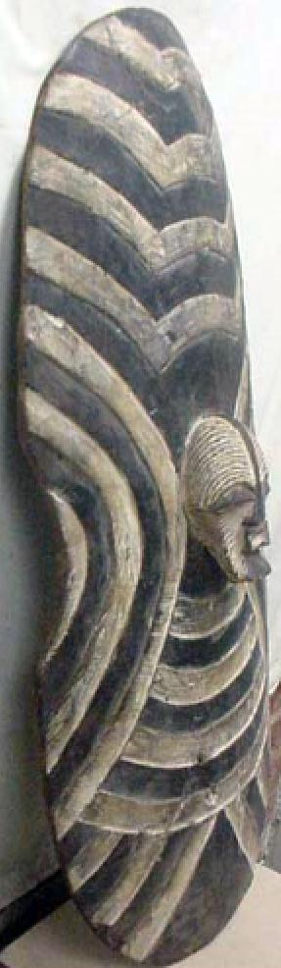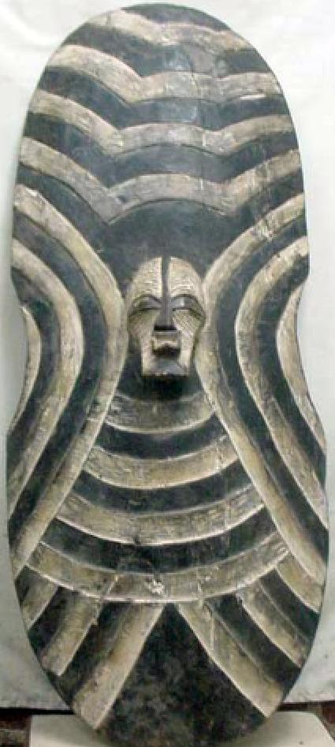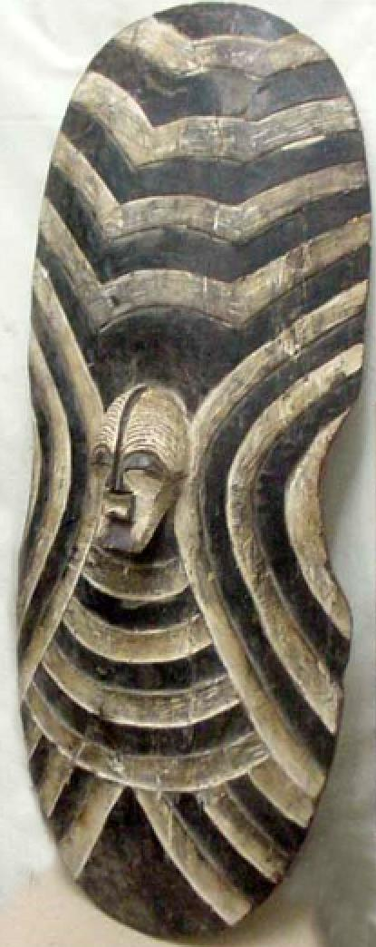

**Figs. 1-3.** Zaire-Songye-Kifwebe-Shield-early 20 th c

**Case no. 6**

Accession No.

Formal Label: Zaire-Songye-Kifwebe-Shield-early 20 th c

**Display Description:**

Rare Kifwebe Songye wooden shield, Evidence of use by the Sonye since the shield has cracks that have been repaired in the field.

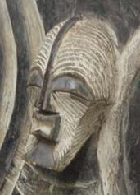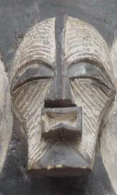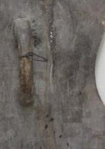

The carved Kifwebe mask in the center is 5.5 in. long. A very similar shield is illustrated in Neyt 2009, p. 363.

The stripes and grooves are reminiscent of the maze that the Bushishi initiates must negotiate. The crest of the forehead signifies the mountains in the east where the sun rises. The magical powers of the male mask, biwebe balume, are associated.

**LC Classification:**

Date or Time Horizon:

Geographical Area:

**Map:**

**GPS coordinates:**

Cultural Affiliation:

Media:

Dimensions: 36 in. long, width 14.5 in. to 12 in., handle 7.5 in. long.

Weight:

Condition:

Provenance:

**Discussion:**

**References:**

Hersak, Dunja. 1993. The kifwebe masking phenomenon. In Herreman, F. ; Petridis, C. eds., *Face of the spirits*, Antwerp: Antwerp: Ethnographic Museum, pp. 145-161.

Neyt, François. 1999. *Songye: The formidable statuary of central Africa*. Munich: Prestel.